

**ST. PAUL’S UNIVERSITY**

**(LIMURU CAMPUS)**

**FACULITY OF COMPUTER SCIENCE AND COMMUNICATION STUDIES**

**BCS 3106: SOFTWARE ENGINEERING II**

**ASSIGNMENT: INITIAL DOCUMENTS FOR SEMESTER PROJECT**

**GROUP E:**

**BSCLMR110623**

**BSCLMR151323**

**BSCLMR150723**

**BSCLMR328421**

**BSCLMR101721**

**BSCLMR106823**

**LECTURER(S): Cecilia Nanfuka**

**DATE OF SUBMISSION: 20th February, 2024**

**PROJECT PLAN**

**1.Requirements Gathering:**

**Interviews:** University council, administrators and students who have ever taken part in the election.

**Document review:**Election procedures & university student information databases.

**Research:**Similar candidates’ application forms in other universities and secure voting systems good enough to be adapted for the nomination process.

**2. System Design & Modelling:**

**Architecture diagram:**All components of a system as well as relationships between them.

**Data flow diagrams (DFDs):** Functions such as user functionality, nomination functionality and reporting functionality among others.

**Entity-relationship diagram (ERD):** User, nomination and position entities with attributes and relationships among these three entities.

**Use case diagrams:** Various users using multiple methods of interactions with a system

**3. Development & Testing:**

a)Selection of framework is Flask.  
b)Secure coding practices like password hashing, input validation and data encryption.  
c)Authentication and authorization through role based access control (RBAC).  
d)Unit testing, integration testing and system testing.

**4. Documentation & Delivery:**

a)User manual together with training materials for administrators and students.  
b)Technical documentation containing system architecture, API references and design decisions

c)Software delivery along with documentation to the University Council

**5. Deployment & User Training:**

a) Server deployment: Setting up safe environment with right access controls;  
  
b) User training: Conducting workshops, online tutorials, and support channels;  
  
c) Testing and monitoring: Sustaining seamless running of operations with due consideration to defects solving

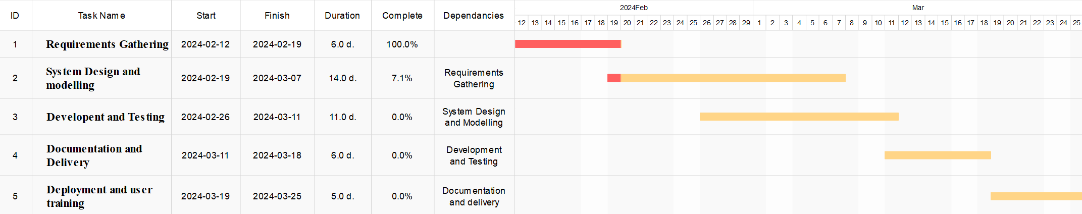

**\*Gantt chart for project plan**

**Software Requirements Specification (SRS)**

**1. Introduction:**

**System name**: University Nomination Application  
  
**Purpose**: To facilitate secure and efficient student nominations for annual campus elections.

**Target audience**: University Council, administrators, registered students.

**2. Functional Requirements:**

**User Roles and Permissions:**

**Student:**

• Check a series of the open nomination categories alongside their explanations.  
• Find eligible nominees by name or other important criteria.  
• Propose a nominee for each category (one nomination per category only).  
• Change or cancel an earlier nomination.

**Council members(admins):**

• Get information about any nominations for all categories.  
• Narrow down nominations through candidates, selection title or keyword.  
• Export nominations data for analysis purposes.  
•Closing and opening of nominations periods is done by admins including management of deadlines.  
• Admins are able to create, amend and delete user accounts (student & admin).

**Nomination Process:**

• Registered students can nominate themselves or other students for specific positions  
• Nominations include candidate information (name, program, platform)  
• A student may make one nomination per position only  
• The voting process is anonymous; therefore, no student or admin can see who nominated whom  
.• Secure storage of nomination data in a tamper-proof database

**Reporting:**

.• Nomination received reports by admins  
.• Tallies show candidate names and counts without disclosing voters  
.• Data in different file format like PDF/CSV can be exported to other systems

**3. Technical Requirements**

**Programming language**: Python Programming Language version 3.7 onwards   
**Web framework**: Flask   
**Database**: Secure as well as scalable database system like MySQL

**Authentication**: University system connect   
**Security**: Implement proper security measures including encryption, data protection and vulnerability patching.  
**User interface**: The application should be easy for students as well as council members to use on their own.

**4.Security Requirements**

**Authentication**: Authentication of a user with valid university credentials shall be required in order to access the application.  
  
**Authorization**: User roles must be clearly defined and access to functions must be restricted according to these roles.  
  
**Data encryption**: All critical information such as student IDs, and nominations should be encrypted in transit as well as at storage points.  
  
**Password protection**: Strong password policies should be enforced, including minimum length, complexity requirements, and regular password changes.

**5.Non-Functional Requirements**

**Performance**: Nominations’ demand response which is quick and efficient.  
  
**Scalability**: Application should handle numerous concurrent users during peak nomination periods.  
  
**Usability**: This software has an intuitive user interface that works for any kind of user. Instructions are clear; error messages are given.  
  
**Accessibility**: Works across various devices and browsers.

**Responsibility Trace Matrix (RTM):**

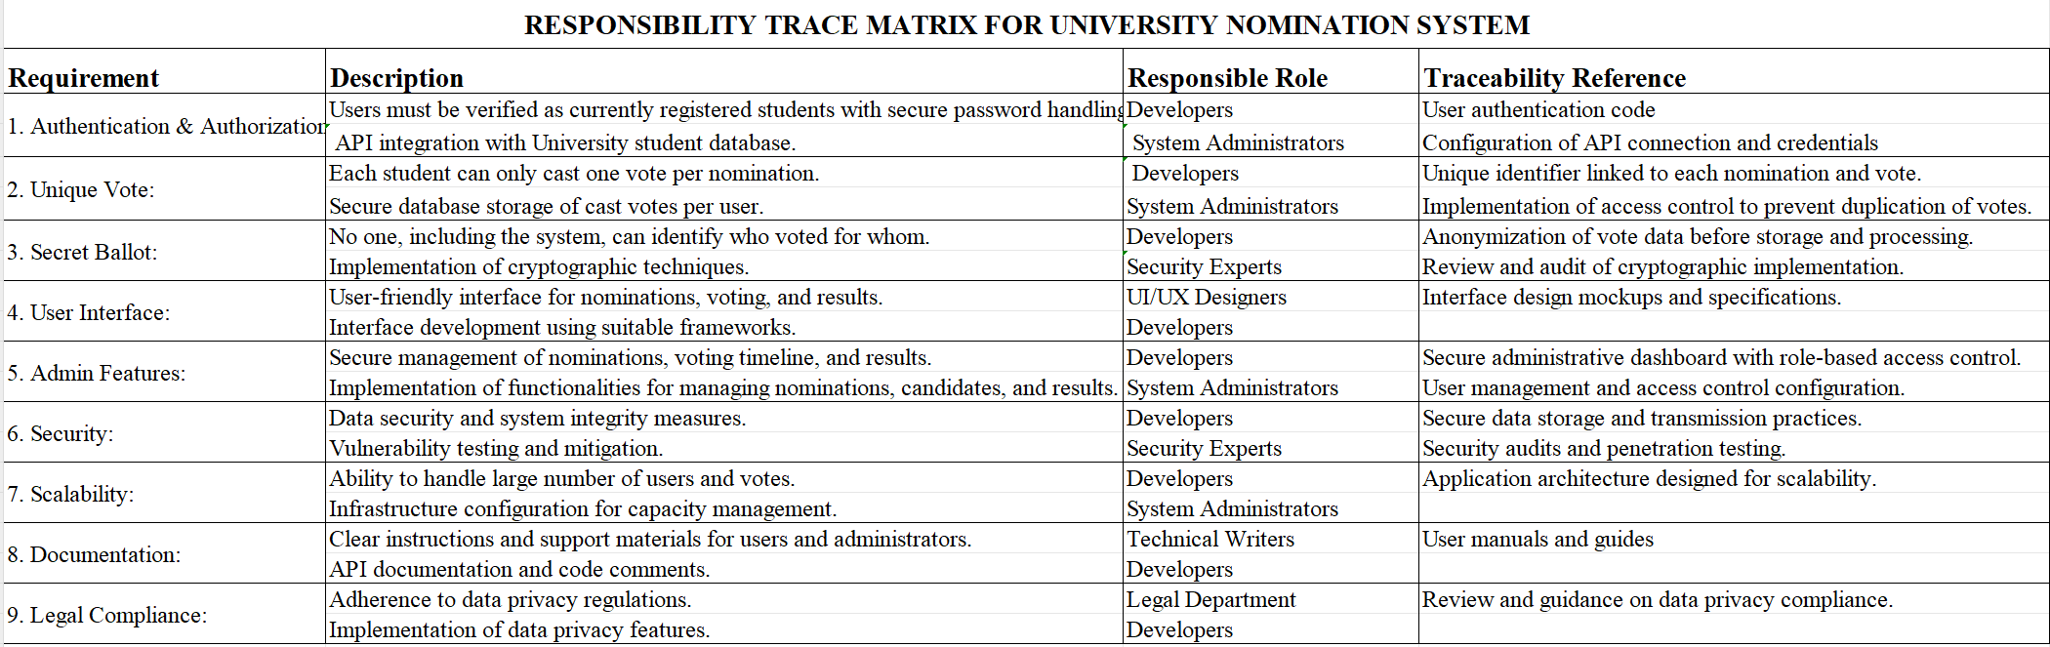

**Group github folder link**: https://github.com/philmanga/Group-E-SE2.git

**REFERENCES**

Pressman, R. S., & Dr, B. R. M. (n.d.). *Software Engineering: A Practitioner’s Approach*. McGraw-Hill Education.

Fowler, M. (n.d.). *UML Distilled: A Brief Guide to the Standard Object Modelling Language*. Addison-Wesley Professional.

IEEE SA. (n.d.). *IEEE Standards Association*. IEEE Standards Association. <https://standards.ieee.org/standard/830-1998.html>

Wikipedia contributors. (2024, February 11). *Blind signature*. Wikipedia. <https://en.wikipedia.org/wiki/Blind_signature>

*Flask-Login — Flask-Login 0.6.3 documentation*. (n.d.). <https://flask-login.readthedocs.io/en/stable/>

*Cybersecurity Framework | NIST*. (2024, February 1). NIST. <https://www.nist.gov/cyberframework>

*Welcome to Flask — Flask Documentation (2.2.x)*. (n.d.). <https://flask.palletsprojects.com/en/2.2.x/>

*OWASP Top 10:2021*. (n.d.). <https://owasp.org/Top10/>